**Data Structures**

Aim:

To retrieve Student Data from a Text File with the Option of Sorting and Searching.

GitHub link:

<https://github.com/Sukirthalakshmanan1/Sort_search>

Procedure:

Step 1:Write the content in text file.

Step 2: Create a Visual studio Windows console project.Write the code in sort.cs

Step 3:Inherit the text file in our code.

Sort:Sort the data using name using regex function. Split by (,) and sort the names.

Search:To find the word in the content of the text file use contains keyword it searches the word and displays the line.

Step 4:create a repository in Github via visual studio

Step 5:Commit all the changes and Push the code to Github.

Output:

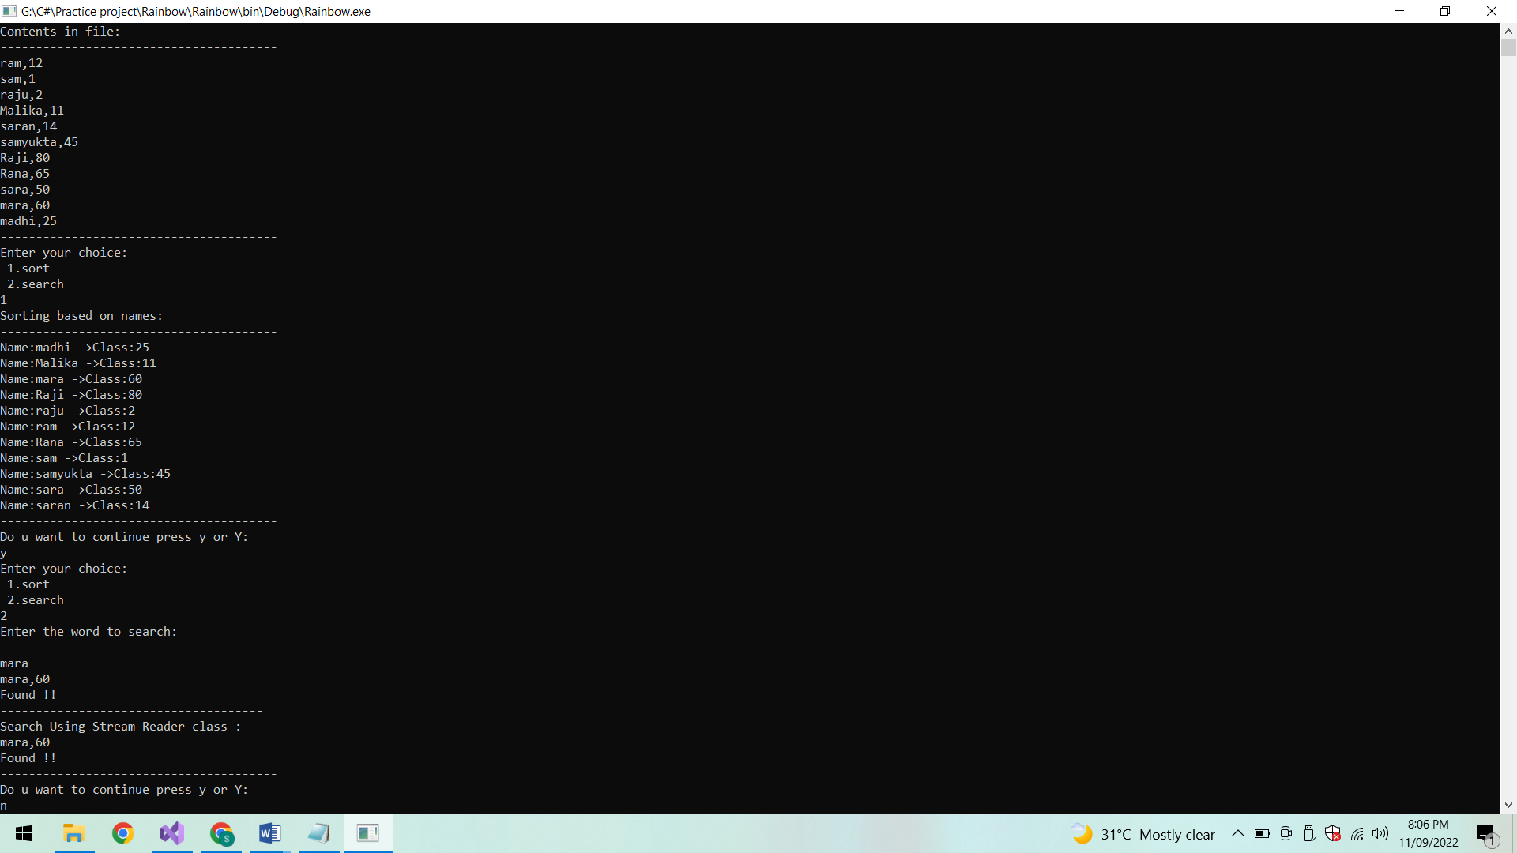

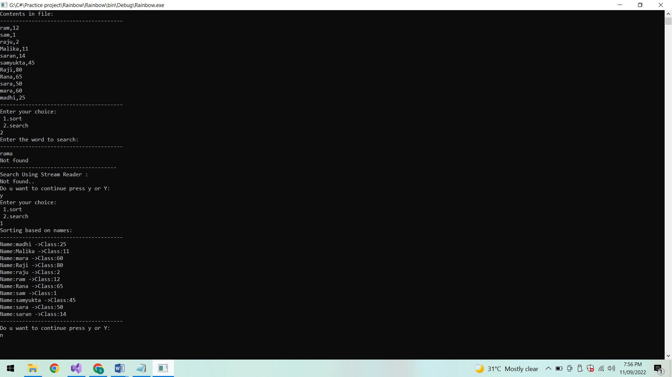

Conclusion:

Thus Student Data can be retrieved from a text file and sorting and searching operations are done.